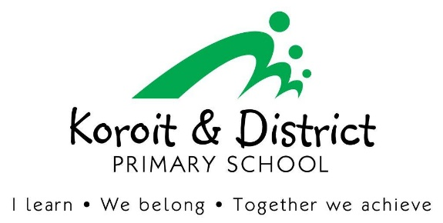
Dear Parent/Guardian,
Koroit & District Primary School is looking forward to another great year of teaching and learning and would like to advise you of Koroit and District Primary School’s voluntary financial contributions for 2026.
Schools provide students with free instruction to fulfil the standard curriculum requirements, and we want to assure you that all contributions are voluntary. Nevertheless, the ongoing support of our families ensures that our school can offer the best possible education and support for our students. We want to thank you for all your support, whether that is through fundraising or volunteering your time. This has made a huge difference to our school and the programs we can offer.
Within our school this support has allowed us to provide: -
- Enhanced Digital learning opportunities within all subjects
- Enhanced Incursions & Excursions
- Enhanced Specialist classes e.g. Connect, STEAM, Performing Arts, Eco Connect.
- Upgrades of school reading resources & facilities
- Refurbishment of school grounds
- Extra sporting events

For further information on the Department’s Parent Payments Policy please see a one-page overview attached.

Yours sincerely,

Principal
Tanya McPherson

School Council President
Sophie Fisk
Curriculum Contributions - items and activities that students use, or participate in, to access the Curriculum | Amount
Specialist Subjects – STEAM, ECO Connect, Performing Arts, Physical Education. | $50.00
IPAD devices – provision of devices from the shared classroom sets (F-6) | $50.00
Swimming and water safety program (Subsidised by DET) | $50.00
Athletics Carnival | $10.00
Printing and photocopying of worksheets and learning materials | $20.00
Total Curriculum Contributions | $180.00
Other Contributions - for non-curriculum items and activities | Amount
Student Wellbeing programs (Connect, Mental Health & Wellbeing, Tutoring) | $30.00
First aid equipment (Band aids, ice packs) | $10.00
School grounds maintenance and improvements | $35.00
Online Student programs (Seesaw, XUNO, Dibels) | $20.00
Total Other Contributions | $95.00
Educational items for students to own.
A list of items that the school recommends you purchase from Winc for your child to individually own and use can be provided on request.
 | Stationary Items for Classroom use via WINC education:  Classroom consumables,  Order via below link:  https://www.wincschools.com.au/  Select School: Koroit & District P S  Code: 5XV8Y  All orders completed before the 5th of December have no delivery charge.  materials & equipment –  Paid via Book pack through Winc.  - Mathematics –  - English –  
  F: $86.57
  1: $87.56
  2: $104.62
  3: $90.94
  4: $91.22
  5/6: $109.09
Extra-Curricular Items and Activities – provided on a user-pays basis
Koroit & District Primary School offers a range of optional items and activities that enhance or broaden the schooling experience of students and are above and beyond what the school provides to deliver the Curriculum.
Extra-Curricular Items and Activities |  |  | Amount
Hoop Time (Grade 3-6) |  |  | $15.00
Tennis Bus Fee (Grades 3-6) |  |  | $5.00
Cross Country/ Soccer Bus Fee (Grades 3-6) |  |  | $5.00
Winter Sports Bus Fee (Grades 3-6) |  |  | $5.00
Grade 6 Graduation (Memento, supper, celebration) |  |  | $40.00
*Any additional activities will be advised at the time of activity. |  |  | TBA
Total Extra-Curricular Items and Activities |  |  | $30.00 (not including Camp)

Financial Support for Families
Koroit & District Primary School understands that some families may experience financial difficulty and offers a range of support options, including:
- The Camps, Sports and Excursions Fund (CSEF) – Families who qualify with a health care card may access CSEF funding towards camps, swimming, and excursions. Applications for this will be required each year and parents will be advised when applications are accepted. For each primary school student who qualifies, the school will receive $400.00 (2026) which will be credited towards sport, swimming, camps and or excursions.
- State Schools Relief (SSR) – SSR provides support to any Victoria student attending a government school (Primary or secondary or specialist), on the advice of the school. Schools are able to submit an application directly, whenever they believe there is a need to support a student whose family/carers are facing difficulty in providing the appropriate uniform., footwear or educational items for attending school.
- Second hand uniforms on site (when available)
- We encourage Payment plans (Bpay or Direct Debit)- Please contact to organise.
- Centrepay (through Centrelink)
- XUNO (payment plans available)
For a confidential discussion about accessing these services, or if you would like to discuss alternative payment arrangements, contact: Amie Timewell Ph: 03 5565 8332 | Email: koroit.ps@education.vic.gov.au

Total
Category | Totals
Curriculum Contributions | $180.00
Other Contributions (Non-tax deductible) | $95.00
Extra-Curricular Items and Activities | $30.00
Total | $305.00

Payment methods
• Cash • EFTPOS • Centrepay (if you are receiving Centrelink payments) • Families can set up regular Bpay

Important Information:

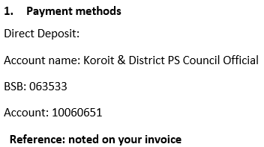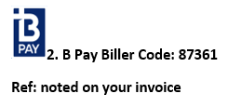

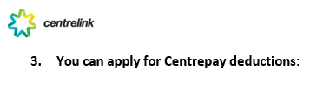
on line at https://www.humanservices.gov.au/individuals/online-help/centrelink/adding-new-centrepay-deduction-using-your-centrelink-online-account

Refunds

Parent requests for refunds are subject to the discretion of the school and made on a case-by-case basis. Refunds will be provided where the school deems it is reasonable and fair to do so, taking into consideration whether a cost has been incurred, the Department’s Parent Payments Policy and Guidance, Financial Help for Families Policy, and any other relevant information.

parent PAYMENTS policy ONE PAGE OVERVIEW
 | FREE INSTRUCTION  - Schools provide students with free instruction and ensure students have free access to all items, activities and services that are used by the school to fulfil the requirements of the Curriculum. This includes the Victorian Curriculum F-10, the Victorian Certificate of Education (VCE) including the VCE Vocational Major and the Victorian Pathways Certificate.  - Schools may invite parents to make a financial contribution to support the school.
 | PARENT PAYMENT REQUESTS  Schools can request contributions from parents under three categories:  - Schools may also invite parents to supply or purchase educational items to use and own (e.g. textbooks, stationery, digital devices).
  Curriculum Contributions  Voluntary financial contributions for curriculum items and activities which the school deems necessary for students to learn the Curriculum. | Other  Contributions  Voluntary financial contributions for non-curriculum items and activities that relate to the school’s functions and objectives. | Extra-Curricular Items and Activities  Items and activities that enhance or broaden the schooling experience of students and are above and beyond what the school provides for free to deliver the Curriculum. These are provided on a user-pays basis.
 | FINANCIAL HELP FOR FAMILIES  - Schools put in place financial hardship arrangements to support families who cannot pay for items or activities so that their child doesn’t miss out.  - Schools have a nominated parent payment contact person(s) that parents can have a confidential discussion with regarding financial hardship arrangements.
 | SCHOOL PROCESSES  - Schools must obtain school council approval for their parent payment arrangements and publish all requests and communications for each year level on their school website for transparency.

